Roll No-12

M.sc. 3rd semester

Date of Assignment-22/11/2020

Date of Submission-25/11/2020

**Experiment No -06**

**Topic**- Tracing the power curve of Poisson Distribution.

**Problem** – Draw the power curve for testing against 

i)  ii) 

Whereis the mean of the Poisson distribution and the significance level is 

**Theory and Calculation**-

Here we are testing against 

Since is a sufficient statistic for therefore the critical region is given by-

 , Where is a constant to be determined such that  Therefore-

 Where 





To find out the value of, we use the following R-command-

k1=qpois(0.95,9.5)

k1

Therefore, k1=15

The C.R. is given by-



Now the power of the test is given by-

Power 

= [Reject is true]



 Where 



Now to draw the power curve we construct the following table considering different values of 

**TABLE**

| lambda | | power | |
| --- | --- | --- | --- |
|  |  | |  |
| 1 | 9.8 | | 0.04213918 |
| 2 | 9.9 | | 0.04535480 |
| 3 | 10.0 | | 0.04874040 |
| 4 | 10.1 | | 0.05229957 |
| 5 | 10.2 | | 0.05603566 |
| 6 | 10.3 | | 0.05995175 |
| 7 | 10.4 | | 0.06405067 |
| 8 | 10.5 | | 0.06833494 |
| 9 | 10.6 | | 0.07280680 |
| 10 | 10.7 | | 0.07746818 |
| 11 | 10.8 | | 0.08232069 |
| 12 | 10.9 | | 0.08736562 |
| 13 | 11.0 | | 0.09260391 |
| 14 | 11.1 | | 0.09803618 |
| 15 | 11.2 | | 0.10366270 |
| 16 | 11.3 | | 0.10948338 |
| 17 | 11.4 | | 0.11549780 |
| 18 | 11.5 | | 0.12170517 |
| 19 | 11.6 | | 0.12810435 |
| 20 | 11.7 | | 0.13469387 |
| 21 | 11.8 | | 0.14147188 |
| 22 | 11.9 | | 0.14843621 |
| 23 | 12.0 | | 0.15558435 |
| 24 | 12.1 | | 0.16291343 |
| 25 | 12.2 | | 0.17042029 |
| 26 | 12.3 | | 0.17810142 |
| 27 | 12.4 | | 0.18595303 |
| 28 | 12.5 | | 0.19397100 |
| 29 | 12.6 | | 0.20215094 |
| 30 | 12.7 | | 0.2104881 |

**Programming in R for case 1-**

library('ggplot2')

k1=qpois(0.95,9.5)

k1

lambda=seq(from=9.8, by=0.1, length.out=30)

power=mat.or.vec(30,1)

for(i in 1:30){

power[i]=1-ppois(15,lambda[i])}

power

Table=data.frame(lambda,power)

Table

View(Table)

ggplot(data=Table,mapping=aes(x=lambda,y=power))+geom_point()+geom_line()

data.frame(lambda)

data.frame(power)

**Power curve by using ggplot 2**



**Power curve generated by using Tableau**

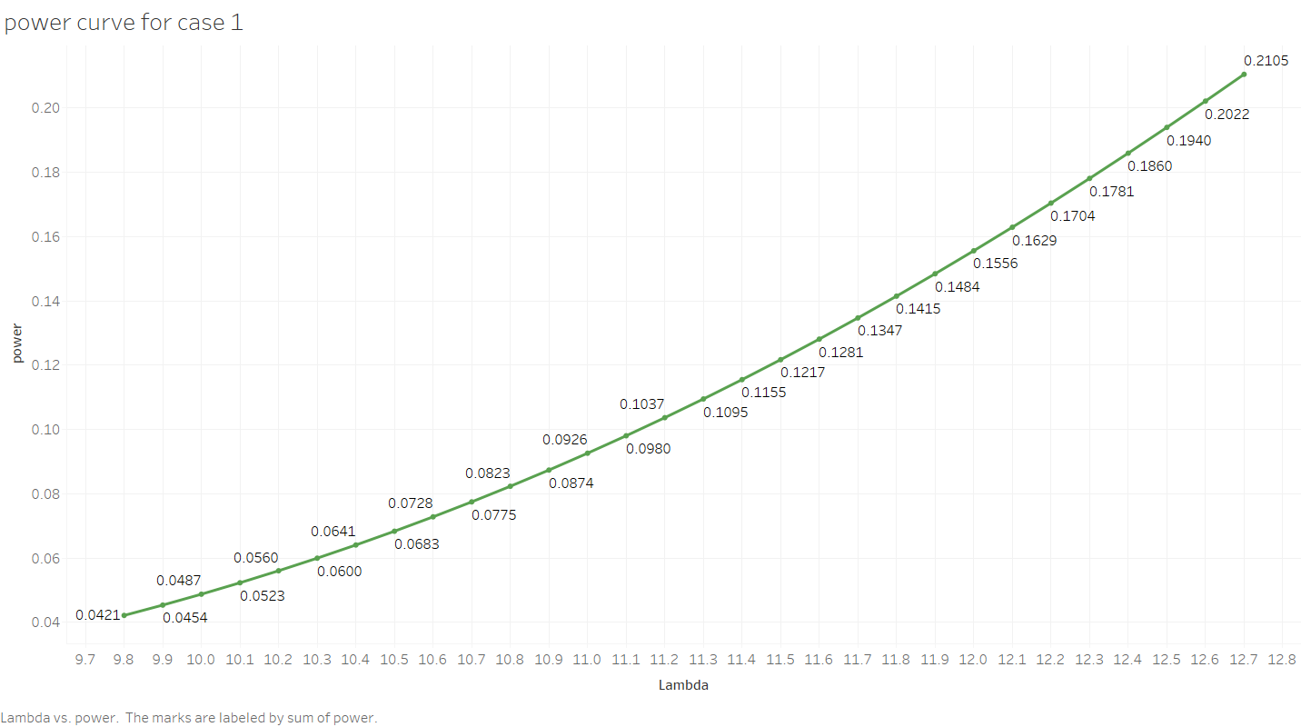

ii) For testing against , the C.R. is given by-

 , Where is a constant to be determined such that . Therefore,







To find out the values of , we use the following R-command-

k2_1=qpois(0.05,9.5)

k2_1

Therefore, k2-1=5 => k2=6

The C.R. is given by- 

Power of the test is given by-

Power== [Reject is true]







Now to draw the power curve, we construct the following table considering different trial values of 

**TABLE**

| **lambda** | | **power** | |
| --- | --- | --- | --- |
|  |  | |  |
| **1** | 6.2 | | 0.4141130 |
| **2** | 6.3 | | 0.3987717 |
| **3** | 6.4 | | 0.3837437 |
| **4** | 6.5 | | 0.3690407 |
| **5** | 6.6 | | 0.3546730 |
| **6** | 6.7 | | 0.3406494 |
| **7** | 6.8 | | 0.3269771 |
| **8** | 6.9 | | 0.3136619 |
| **9** | 7.0 | | 0.3007083 |
| **10** | 7.1 | | 0.2881194 |
| **11** | 7.2 | | 0.2758975 |
| **12** | 7.3 | | 0.2640432 |
| **13** | 7.4 | | 0.2525566 |
| **14** | 7.5 | | 0.2414365 |
| **15** | 7.6 | | 0.2306808 |
| **16** | 7.7 | | 0.2202869 |
| **17** | 7.8 | | 0.2102511 |
| **18** | 7.9 | | 0.2005691 |
| **19** | 8.0 | | 0.1912361 |
| **20** | 8.1 | | 0.1822465 |
| **21** | 8.2 | | 0.1735944 |
| **22** | 8.3 | | 0.1652734 |
| **23** | 8.4 | | 0.1572768 |
| **24** | 8.5 | | 0.1495973 |
| **25** | 8.6 | | 0.1422276 |
| **26** | 8.7 | | 0.1351600 |
| **27** | 8.8 | | 0.1283866 |
| **28** | 8.9 | | 0.1218995 |
| **29** | 9.0 | | 0.1156905 |
| **30** | 9.1 | | 0.1097514 |

**Programming in R for case 2-**

library('ggplot2')

k2=6

k2_1=5

lambda=seq(from=6.2, by=0.1, length.out=30)

power=mat.or.vec(30,1)

for(i in 1:30){

power[i]=ppois(k2_1,lambda[i])}

power

Table=data.frame(lambda,power)

Table

View(Table)

ggplot(data=Table,mapping=aes(x=lambda,y=power))+geom_point()+geom_line()

data.frame(lambda)

data.frame(power)

**Power curve by using ggplot 2**



**Power curve generated by using Tableau**

